Question 01

Q: WAP to demonstrate the usage of escape sequences

(\n, \t, \b, \\, \", \')

Source Code

// WAP to demonstrate the usage of escape sequences (\n, \\, \t, \b, \", \')

#include<stdio.h>

int main(){

    printf("Program to demonstrate the usage of escape sequences: \n");

    printf("This statement started from the next line as a newline character (\\n) is used at the end of previous print statement.\n");

    printf("In previous line the Backslash Escape character (\\\\) is used. \n");

    printf("\t<--- Here 4 Tab Spaces are given using Horizontal Tab (\\t). \n");

    printf("Backspace Character (\\b) to move cursor  \bone character back.\n");

    printf("Using Double Quote (\\\") \"To print the Double Quotes\". \n");

    printf("Using Single Quote (\\\') \'To print the Single Quotes\'. \n");

    return 0;

}

Output

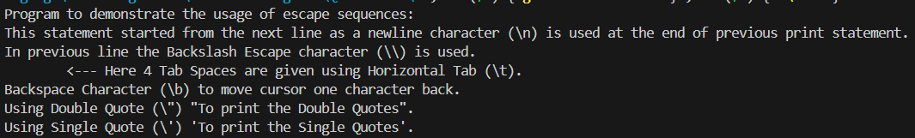

Question 02

Q: WAP to study variables and constants of int and float data types.

Source Code

// WAP to study variables and constants of int and float data types

#include <stdio.h>

int main() {

    // Declaring and initializing integer variables

    int intVar1 = 10;

    int intVar2 = 20;

    // Declaring and initializing float variables

    float floatVar1 = 12.5;

    float floatVar2 = 30.75;

    // Declaring and initializing constants using 'const' keyword

    const int intConst = 100;    // Integer constant i.e cannot be updated

    const float floatConst = 50.25; // Float constant i.e cannot be updated

    // Printing values of integer variables

    printf("Integer Variable 1: %d\n", intVar1);

    printf("Integer Variable 2: %d\n", intVar2);

    // Printing values of float variables

    printf("Float Variable 1: %.2f\n", floatVar1);  // .2f to print 2 decimal places

    printf("Float Variable 2: %.2f\n", floatVar2);

    // Printing values of integer and float constants

    printf("Integer Constant: %d\n", intConst);

    printf("Float Constant: %.2f\n", floatConst);

    return 0;

}

Output

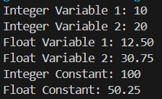

Question 03

Q: WAP to read two variables of type int and float. Read their values from the user and print the values

Source Code

// WAP to read two variables of type int and float. Read their values from the user and print the values

#include<stdio.h>

int main(){

    int intNo;

    float floatNo;

    // Scanning Values

    printf("Enter Integer Value: ");

    scanf("%d", &intNo);

    printf("Enter a Float Value: ");

    scanf("%f", &floatNo);

    // Printing Values

    printf("Your Integer Number is : %d\n", intNo);

    printf("Your Float Number till 4 decimal place is: %.4f", floatNo);

    return 0;

}

Output

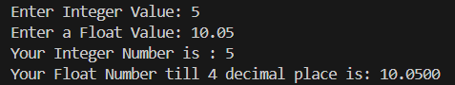

Question 04

Q: WAP to read two integers from user and print both the numbers. Find their sum and assign it to third variable

Source Code

//WAP to read two integers from user and print both the numbers. Find their sum and assign it to third variable

#include<stdio.h>

int main(){

    int no1,no2;

    int sum;

    printf("Enter Two Integer Value: ");

    scanf("%d %d", &no1, &no2);

    printf("The Numbers are %d & %d.\n", no1, no2);

    sum = no1 + no2;

    printf("The Sum of %d + %d is %d", no1,no2,sum);

    return 0;

}

Output

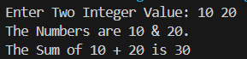

Question 05

Q: WAP to read numbers for five subjects and print their sum and average.

Source Code

//WAP to read numbers for five subjects and print their sum and average.

#include<stdio.h>

int main(){

    int math,sci,hin,eng,it;

    int sum,avg;

    printf("Enter Maths Marks: ");

    scanf("%d", &math);

    printf("Enter Science Marks: ");

    scanf("%d", &sci);

    printf("Enter Hindi Marks: ");

    scanf("%d", &hin);

    printf("Enter English Marks: ");

    scanf("%d", &eng);

    printf("Enter Information Technology Marks: ");

    scanf("%d", &it);

    sum = math+sci+hin+eng+it;

    avg = sum/5;

    printf("Total Marks are %d and Average is %d", sum, avg);

    return 0;

}

Output

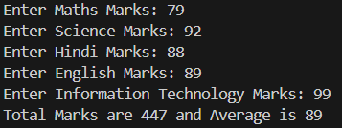

Question 06

Q: WAP to read two floating type numbers from user. Calculate their sum, difference, product and average

Source Code

//WAP to read two floating type numbers from user. Calculate their sum, difference, product and average

#include<stdio.h>

int main(){

    float no1,no2;

    float sum,diff,prod,avg;

    printf("Enter Two Float Numbers: ");

    scanf("%f %f", &no1, &no2);

    sum = no1+no2;

    diff = no1-no2;

    prod = no1*no2;

    avg = sum/2;

    printf("Sum is %.4f\n", sum);

    printf("Difference is %.4f\n", diff);

    printf("Product is %.4f\n", prod);

    printf("Average is %.4f\n", avg);

    return 0;

}

Output

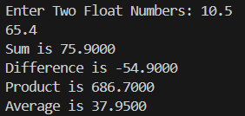

Question 07

Q: WAP to read Principle amount and time for a loan application.

Take Rate of interest as a symbolic constant. Calculate Simple interest and display results

Source Code

/*WAP to read Principle amount and time for a loan application.

Take Rate of interest as a symbolic constant. Calculate Simple interest and display results*/

#include<stdio.h>

int main(){

    int p,t,si,res;

    const int r;

    printf("Enter Principle Amount: ");

    scanf("%d", &p);

    printf("Enter Rate of Intrest: ");

    scanf("%d", &r);

    printf("Enter Time Duration: ");

    scanf("%d", &t);

    si = (p*r*t)/100;

    res = p+si;

    printf("Simple Interest after %d years is %d\n", t, si);

    printf("Total Amount after %d years is %d", t, res);

}

Output

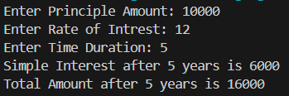

Question 08

Q: WAP to read temperature in Celsius and convert it to Fahrenheit and vice-versa. Display the results of the program

Source Code

//WAP to read temperature in Celsius  and convert it to Fahrenheit  and vice-versa. Display the results of the program

#include<stdio.h>

int Fahrenheit (){

    float c,f;

    printf("Enter Temparature in Celsius : ");

    scanf("%f", &c);

    f = (9.0/5.0*c)+32;

    printf("%.2f*C is %.2f*F", c,f);

}

int Celsius (){

    float c,f;

    printf("Enter Temparature in Fahrenheit : ");

    scanf("%f", &f);

    c = (5.0/9.0)*(f-32);

    printf("%.2f*F is %.2f*C", f,c);

}

int main(){

    int choice;

    printf("Would you Like to Input in Celsius  of Fahrenheit ? (c/f): ");

    scanf("%c", &choice);

    (choice == 'f')? Celsius () : Fahrenheit ();

}

Output

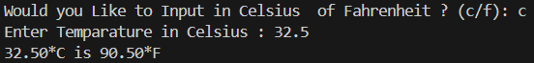

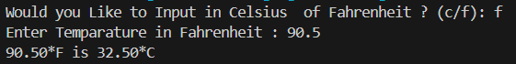

Question 09

Q: To swap two numbers using third variable

Source Code

// To swap two numbers using third variable

#include<stdio.h>

int main(){

    int a,b,c;

    printf("Enter two Numbers to be Swapped: ");

    scanf("%d %d", &a,&b);

    printf("\n First Number is: %d", a);

    printf("\n Second Number is: %d", b);

    c = a;

    a = b;

    b = c;

    printf("\n Now First Number is: %d", a);

    printf("\n and Second Number is: %d", b);

    return 0;

}

Output

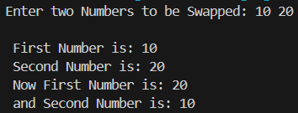

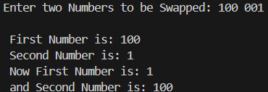

Question 10

Q: To swap two numbers without using third variable

Source Code

// To swap two numbers without using third variable

#include<stdio.h>

int main(){

    int a, b;

    printf("Enter two numbers: ");

    scanf("%d %d", &a, &b);

    printf("\n First Number is: %d", a);

    printf("\n Second Number is: %d", b);

    a = a + b;

    b = a - b;

    a = a - b;

    printf("\n Now First Number is: %d", a);

    printf("\n and Second Number is: %d", b);

    return 0;

}

Output

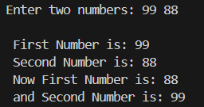

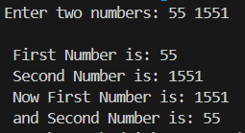

Question 11

Q: Read input from user at runtime and convert time from

  -hours to seconds

  -hours to minutes

  -minutes to seconds

Source Code

/* Read input from user at runtime and convert time from

 -hours to seconds

 -hours to minutes

 -minutes to seconds */

#include<stdio.h>

int main(){

    int h,h_m,m,s;

    printf("Enter the Hours: ");

    scanf("%d", &h);

    printf("Enter the Minutes: ");

    scanf("%d", &m);

    s = m*60;

    h_m = h*60;

    printf("\n%d Hours is %d Minutes",h,h_m);

    printf("\n%d Minutes is %d Seconds",m,s);

    return 0;

}

Output

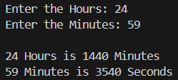

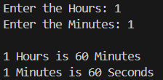

Question 12

Q: To find area and perimeter of rectangle. Read input from user.

Source Code

//To find area and perimeter of rectangle. Read input from user.

#include<stdio.h>

int main(){

    int l,w,a,p;

    printf("Enter Length & Width of the Rectangle: ");

    scanf("%d %d", &l,&w);

    a = l*w;

    p = 2*(l+w);

    printf("\nArea is %d\nPerimeter is %d", a,p);

    return 0;

}

Output

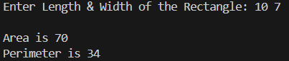

Question 13

Q: To print circumference and area of circle. Read input from user

Source Code

//To print circumference and area of circle. Read input from user

#include<stdio.h>

int main(){

    float r,c,a;

    const float pi = 3.14;

    printf("Enter the Radius of the Circle: ");

    scanf("%f", &r);

    c = 2*pi*r;

    a = pi*r*r;

    printf("\nCircumfrence is %.2f\nArea is %.2f",c,a);

    return 0;

}

Output

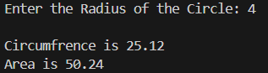

Question 14

Q: To apply mathematical operation on ASCII value of character variables

Source Code

//To apply mathematical operation on ASCII value of character variables

#include<stdio.h>

int main(){

    char ch,ch2;

    int a;

    printf("Enter Letter: ");

    scanf("%c", &ch);

    printf("Enter Increment Number: ");

    scanf("%d", &a);

    ch2 = ch+a;

    printf("\nASCII Value of %c is %d",ch,ch);

    printf("\n%d+%d is %d", ch,a, ch+a);

    return 0;

}

Output

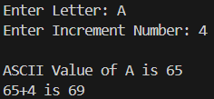

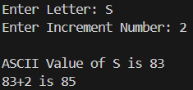

Question 15

Q: Mathematical operation on character to get other character

Source Code

//Mathematical operation on character to get other character

#include<stdio.h>

int main(){

    char ch,ch2;

    int a;

    printf("Enter Letter: ");

    scanf("%c", &ch);

    printf("Enter Increment Number: ");

    scanf("%d", &a);

    ch2 = ch+a;

    printf("\nASCII Value of %c is %d",ch,ch);

    printf("\n%d+%d is %d", ch,a, ch+a);

    printf("\nASCII Letter of %d is %c", ch2,ch2);

    return 0;

}

Output

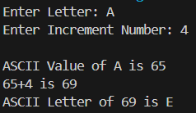

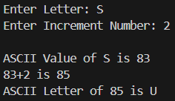

Question 16

Q: WAP to read from user the values for 3 products (item_no, quantity, price).

Find the total bill value and display.

Also, allow a discount of 10% on the total bill and display net bill value

Source Code

/*WAP to read from user the values for 3 products (item_no, quantity, price).

Find the total bill value and display.

Also, allow a discount of 10% on the total bill and display net bill value*/

#include<stdio.h>

int main(){

    int prod1[3], prod2[3],prod3[3];

    int i,j,bill,netBill;

    for(i=0;i<3;i++){

        printf("Enter Details for Product %d\n", i+1);

        if(i==0){

            printf("  Enter Item-Number, Quantity & Price: ");

            scanf("%d %d %d", &prod1[0], &prod1[1], &prod1[2]);

        }

        else if(i==1){

            printf("  Enter Item-Number, Quantity & Price: ");

            scanf("%d %d %d", &prod2[0], &prod2[1], &prod2[2]);

        }

        else if(i==2){

            printf("  Enter Item-Number, Quantity & Price: ");

            scanf("%d %d %d", &prod3[0], &prod3[1], &prod3[2]);

        }

    }

    bill = prod1[2] + prod2[2] + prod3[2]; // total bill value

    netBill = bill-bill*0.1;               // net bill value

    printf("Total Bill: %d\n", bill);

    printf("Net Bill: %d", netBill);

    return 0;

}

Output

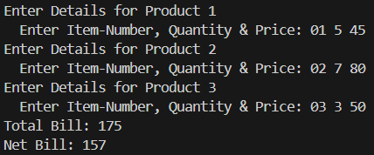

Question 17

Q: To find maximum of two numbers, using Conditional operator

Source Code

//To find maximum of two numbers by using Conditional operator

#include<stdio.h>

int main(){

    int a,b;

    printf("Enter Two Numbers: ");

    scanf("%d %d", &a,&b);

    (a>b)? printf("%d is Greater then %d", a,b) : printf("%d is Greater than %d", b,a);

    return 0;

}

Output





Question 18

Q: To find maximum of three numbers, using Conditional operator

Source Code

//To find maximum of three numbers using Conditional operator

#include<stdio.h>

#define aG printf("%d is Greater than %d and %d",a,b,c)

#define bG printf("%d is Greater than %d and %d",b,a,c)

#define cG printf("%d is Greater than %d and %d",c,a,b)

int main(){

    int a,b,c;

    printf("Enter Three Numbers: ");

    scanf("%d %d %d", &a,&b,&c);

    (a>b && a>c)? aG : (b>a && b>c)? bG : cG;

    return 0;

}

Output





Question 19

Q: To find maximum of two numbers by using if else statement

Source Code

//To find maximum of two numbers by using if else statement

#include<stdio.h>

int main(){

    int a,b;

    printf("Enter Two Numbers: ");

    scanf("%d %d", &a,&b);

    if(a>b){

        printf("%d is Greator than %d",a,b);

    }

    else{

        printf("%d is Greator than %d",b,a);

    }

    return 0;

}

Output



Question 20

Q: To find maximum of three numbers by if else if statement

Source Code

//To find maximum of three numbers by if else if statement

#include<stdio.h>

#define aG printf("%d is Greater than %d and %d",a,b,c)

#define bG printf("%d is Greater than %d and %d",b,a,c)

#define cG printf("%d is Greater than %d and %d",c,a,b)

int main(){

    int a,b,c;

    printf("Enter Three Numbers: ");

    scanf("%d %d %d", &a,&b,&c);

    if(a>b && a>c)

    aG;

    else if(b>a && b>c)

    bG;

    else

    cG;

    return 0;

}

Output



Question 21

Q: To find grades on the basis of marks, using if-else and relational operators.

 Average marks Grade:

 80 to 100 Honours

 60 to 79 First Division

 50 to 59 Second Division

 40 to 49 Third Division

 0 to 39 Fail

Source Code

/*To find grades on the basis of marks, using if-else and relational operators

#include <stdio.h>

int main() {

    int marks;

    printf("Enter the Average Marks (0 - 100): ");

    scanf("%d", &marks);

    if (marks >= 80 && marks <= 100) {

        printf("Grade: Honours\n");

    }

    else if (marks >= 60 && marks <= 79) {

        printf("Grade: First Division\n");

    }

    else if (marks >= 50 && marks <= 59) {

        printf("Grade: Second Division\n");

    }

    else if (marks >= 40 && marks <= 49) {

        printf("Grade: Third Division\n");

    }

    else if (marks >= 0 && marks <= 39) {

        printf("Grade: Fail\n");

    }

    else {

        printf("Invalid marks. Please enter a value between 0 and 100.\n");

    }

    return 0;

}

Output





Question 22

Q: To find electricity charges based on consumption

 Consumption Units Rate of Charge

 0 – 200 Rs. 0.50 per unit

 201 – 400 Rs. 100 plus Rs. 0.65 per unit excess of 200

 401 – 600 Rs. 230 plus Rs. 0.80 per unit excess of 400

 601 and above Rs. 390 plus Rs. 1.00 per unit excess of 600

Source Code

/*To find electricity charges based on consumption

 Consumption Units Rate of Charge

 0 – 200 Rs. 0.50 per unit

 201 – 400 Rs. 100 plus Rs. 0.65 per unit excess of 200

 401 – 600 Rs. 230 plus Rs. 0.80 per unit excess of 400

 601 and above Rs. 390 plus Rs. 1.00 per unit excess of 600*/

#include <stdio.h>

int main(){

    int units;

    float totalCharge;

    printf("Enter the number of units consumed: ");

    scanf("%d", &units);

    if (units <= 200) {

        totalCharge = units * 0.50;

    }

    else if (units <= 400) {

        totalCharge = 100 + (units - 200) * 0.65;

    }

    else if (units <= 600) {

        totalCharge = 230 + (units - 400) * 0.80;

    }

    else {

        totalCharge = 390 + (units - 600) * 1.00;

    }

    printf("Total electricity charge: Rs. %.2f\n", totalCharge);

    return 0;

}

Output







Question 23

Q: WAP to read two integers and an operator (+,-,*,/,%). Use switch-case statement to get result of operator on two integers.

Source Code

//WAP to read two integers and an operator (+,-,*,/,%).

int main(){

    int num1, num2, result;

    char operator;

    printf("Enter first number: ");

    scanf("%d", &num1);

    printf("Enter second number: ");

    scanf("%d", &num2);

    printf("Enter an operator (+, -, *, /, %%): ");

    scanf(" %c", &operator); //The Space before %c to ignore any newline character in buffer.

    switch (operator){

        case '+':

            result = num1 + num2;

            printf("Result: %d + %d = %d\n", num1, num2, result);

            break;

        case '-':

            result = num1 - num2;

            printf("Result: %d - %d = %d\n", num1, num2, result);

            break;

        case '*':

            result = num1 * num2;

            printf("Result: %d * %d = %d\n", num1, num2, result);

            break;

        case '/':

            if (num2 != 0) {

                result = num1 / num2;

                printf("Result: %d / %d = %d\n", num1, num2, result);

            }

            else {

                printf("Error: Division by zero is not allowed.\n");

            }

            break;

        case '%':

            if (num2 != 0) {

                result = num1 % num2;

                printf("Result: %d %% %d = %d\n", num1, num2, result);

            }

            else {

                printf("Error: Modulus by zero is not allowed.\n");

            }

            break;

        default:

            printf("Invalid operator.\n");

            break;

    }

    return 0;

}

Output

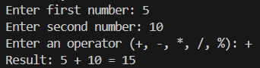

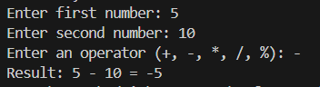

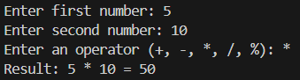

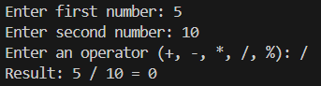

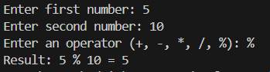

Question 24

Q: To find nature of roots of quadratic equations

Source Code

//To find nature of roots of quadratic equations

#include<stdio.h>

#include<math.h>

int main(){

    int a,b,c,D;

    float root1, root2, realRoot, imgRoot;

    printf("Enter Coefficients a, b & c: ");

    scanf("%d%d%d",&a,&b,&c);

    D = (b*b)-4*a*c; // finding discriminant

    if(D > 0){

        printf("As D(%d) is Greater than 0\n", D);

        root1 = (-b + sqrt(D)) / (2*a);

        root2 = (-b - sqrt(D)) / (2*a);

        printf("The equation has Two Distinct real roots: %.2f and %.2f\n", root1, root2);

    }

    else if(D == 0){

        printf("As D(%d) is equal to 0\n", D);

        root1 = -b / (2 * a);

        printf("The equation has two equal real roots: %.2f\n", root1);

    }

    else{

        printf("As D(%d) is Less than 0\n", D);

        realRoot = -b / (2 * a);

        imgRoot = sqrt(-D) / (2 * a);

        printf("The equation has two complex roots: %.2f + %.2fi and %.2f - %.2fi\n", realRoot, imgRoot, realRoot, imgRoot);

    }

    return 0;

}

Output

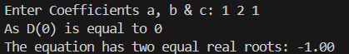

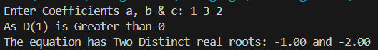

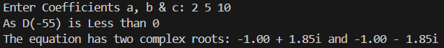

Question 25

Q: WAP to print natural numbers till n using while loop. Also print reverse counting from m to 1. Get m,n from user at runtime

Source Code

//WAP to print natural numbers till n using while loop. Also print reverse counting from m to 1. Get m,n from user at runtime

#include <stdio.h>

int main(){

    int m, n, i = 1;

    printf("Enter the Top Limit Number: ");

    scanf("%d", &n);

    printf("Natural Numbers from 1 to %d:\n", n);

    while (i <= n){

        printf("%d\n", i);

        i++;

    }

    printf("Enter the Starting Point for Countdown: ");

    scanf("%d", &m);

    i = m;

    printf("Countdown Start:\n");

    while (i >= 1){

        printf("%d\n", i);

        i--;

    }

    return 0;

}

Output

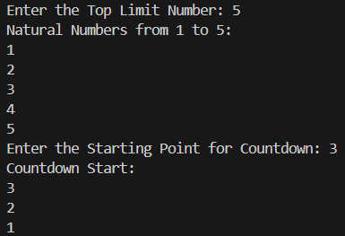

Question 26

Q: WAP to compute xn using while statement.

Source Code

//WAP to compute x^n using while statement

#include <stdio.h>

int main() {

    double x;

    int n;

    double result = 1.0;

    int count = 0;

    printf("Enter the base (x): ");

    scanf("%lf", &x); // %lf is long float specifying a double

    printf("Enter the exponent (n): ");

    scanf("%d", &n);

    // Handle negative exponent case

    if (n < 0) {

        x = 1.0 / x; // Inverting the base for negative exponent

        n = -n; // Making exponent positive

    }

    while (count < n) {

        result *= x;

        count++;

    }

    printf("%.2f^%d = %.2f\n", x, n, result);

    return 0;

}

Output

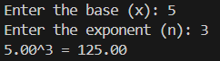

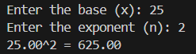

Question 27

Q: WAP to generate multiplication tables using nested do-while statements

Source Code

//WAP to generate multiplication tables using nested do-while statements

#include<stdio.h>

int main(){

    int n,mn,i,j,max;

    printf("Enter Number whose table you want to Print: ");

    scanf("%d",&n);

    printf("Till which Number you want to Multiply: ");

    scanf("%d", &max);

    do{

        i = 1;

        do{

            mn = n*i;

            printf("%d x %d = %d\n",n,i,mn);

            i++;

        }while(i<=max);

        i=0;

    }while(i==1);

    return 0;

}

Output

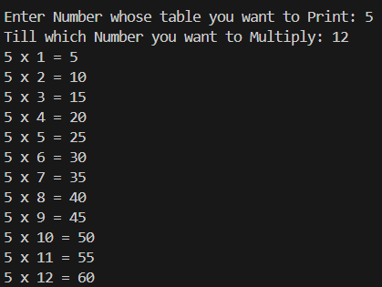

Question 28

Q: WAP to print following patterns: triangle of '*', triangle of digits

Source Code

//WAP to print following patterns: triangle of '*', triangle of digits

#include<stdio.h>

void LrightStarTrng(int r){

    int i,j;

    for(i=1;i<=r;i++){

        for(j=0;j<i;j++){

            printf("*");

        }

        printf("\n");

    }

}

void RrightStarTrng(int r){

    int i,j,s;

    for(i=1;i<=r;i++){

        for(s=0;s<r-i;s++){

            printf(" ");

        }

        for(j=0;j<i;j++){

            printf("*");

        }

        printf("\n");

    }

}

void LrightNumTrng(int r){

    int i,j,n=0;

    for(i=1;i<=r;i++){

        for(j=0;j<i;j++){

            //to prefix 0 in single digit numbers

            (n==0||n==1||n==2||n==3||n==4||n==5||n==6||n==7||n==8||n==9)? printf("0%d ",n) : printf("%d ",n);

            n++;

        }

        printf("\n");

    }

}

void RrightNumTrng(int r){

    int i,j,s,n=0;

    for(i=1;i<=r;i++){

        for(s=0;s<r-i;s++){

            printf("   "); // giving 3 spaces as one extra space in giving at printing

        }

        for(j=0;j<i;j++){

            (n==0||n==1||n==2||n==3||n==4||n==5||n==6||n==7||n==8||n==9)? printf("0%d ",n) : printf("%d ",n);

            n++;

        }

        printf("\n");

    }

}

int main(){

    int i,j,r;

    printf("Enter Number of Rows: ");

    scanf("%d", &r);

    LrightStarTrng(r);

    printf("\n");

    RrightStarTrng(r);

    printf("\n");

    LrightNumTrng(r);

    printf("\n");

    RrightNumTrng(r);

    return 0;

}

Output

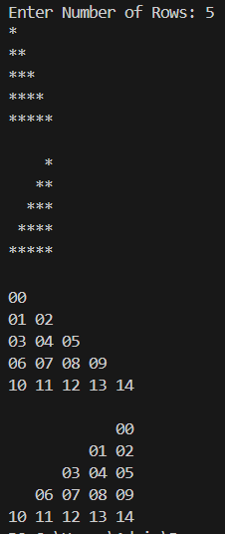 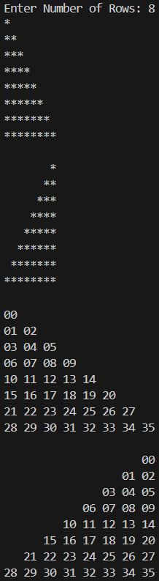

Question 29

Q: To read an integer and print sum of its digits using while loop.

Construct and print reverse of n-digit number using do-while loop.

Source Code

//To read an integer and print sum of its digits using while loop.

//Construct and print reverse of n-digit number using do-while loop.

#include<stdio.h>

int main(){

    int n,og,sumN=0,digit,revN=0;

    printf("Enter Number: ");

    scanf("%d", &n);

    og = n;

    while(n != 0){

        digit = n%10;

        n /= 10;

        sumN += digit;

    }

    printf("Sum of Digits of %d is %d\n", og,sumN);

    n = og;

    do{

        digit = n%10;

        n /= 10;

        revN = revN*10 + digit;

    }while(n!=0);

    printf("Reversed Digits of %d is %d", og,revN);

    return 0;

}

Output

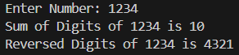

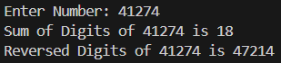

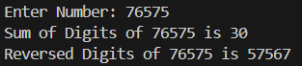

Question 30

Q: To determine if given number is prime or composite

.

Source Code

//To determine if given number is prime or composite

#include<stdio.h>

int main(){

    printf("Program to Find Prime Numbers \n");

    int n, i, j, p;

    printf("Enter the number up to which you want to find prime numbers: ");

    scanf("%d", &n);

    if(n == 2){

        printf("2 is a Prime Number.");

        return 0;

    }

    for(i=2; i<=n;i++){

        for(j=2;j<i;j++){

            if(i%j != 0){

                p = i;

            }

            else{

                p = 0;

                break;

            }

        }

    }

    if(p != 0){

        printf("%d is a Prime Number.",n);

    }

    else{

        printf("%d is a Composite Number.",n);

    }

    return 0;

}

Output

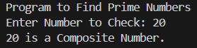

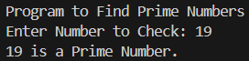

Question 31

Q: To print sum of first n odd natural numbers

Source Code

//To print sum of first n odd natural numbers

#include<stdio.h>

int main(){

    int i,n,sumN=0;

    printf("Enter Number of Elements: ");

    scanf("%d", &n);

    for(i=1;i<=n*2;i+=2){

        printf("i is %d\n",i);

        sumN += i;

    }

    printf("Sum of first %d odd Numbers is %d", n, sumN);

    return 0;

}

Output





Question 32

Q: To print sum of series: (1)+(1/2)+(1/3).....+(1/n)

Source Code

//To print sum of series: (1)+(1/2)+(1/3).....+(1/n)

#include<stdio.h>

int main(){

    int elmN;

    float i,sum;

    printf("Enter Number of Elements: ");

    scanf("%d",&elmN);

    for(i=1.0;i<=elmN;i++){

        sum += 1.0/i;

    }

    printf("Sum is %.2f", sum);

    return 0;

}

Output





Question 33

Q: WAP to implement a function printline(int n, char ch) to print 'ch' n times

Source Code

// WAP to implement a function printline(int n, char ch) to print 'ch' n times

#include<stdio.h>

void printLine(int n, char ch){

    for(int i = 0;i < n;i++){

        printf("%c ", ch);

    }

}

int main(){

    printf("Program to Loop Printing a Character\n");

    int n;

    char ch;

    printf("Enter the String: ");

    scanf(" %c", &ch);

    printf("Enter Number of times to Print: ");

    scanf("%d", &n);

    printLine(n,ch);

}

Output

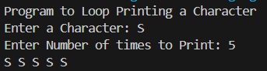

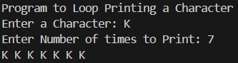

Question 34

Q: Program to find simple interest in a function. Create function with arguments and return type

Source Code

// Program to find simple interest in a function. Create function with arguments and return type

#include<stdio.h>

int simpleInt(int p,int r,int t){

    int SI;

    SI = (p*r*t)/100;

    return SI;

}

int main(){

    printf("Program to find Simple Interest using Function Def\n");

    int p,r,t,SI;

    printf("Enter Principal Amount: ");

    scanf("%d", &p);

    printf("Enter Rate of Intrest : ");

    scanf("%d", &r);

    printf("Enter Time Duration : ");

    scanf("%d", &t);

    SI = simpleInt(p,r,t);

    printf("Simple Intrest is %d", SI);

    return 0;

}

Output

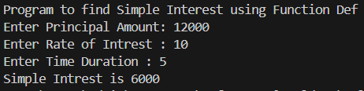

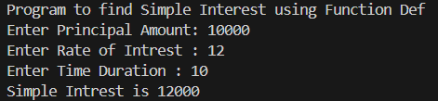

Question 35

Q: Program to Swap two numbers using functions (call by reference)

Source Code

// Program to Swap two numbers using functions (call by reference)

#include<stdio.h>

int swap(int *a, int *b){

    int c;

    c = *a;

    *a = *b;

    *b = c;

}

int main(){

    int a,b;

    printf("Enter A: ");

    scanf("%d", &a);

    printf("Enter B: ");

    scanf("%d", &b);

    swap(&a, &b);

    printf("Value of A after Swap: %d\n", a);

    printf("Value of B after Swap: %d", b);

    return 0;

}

Output

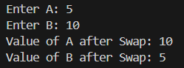

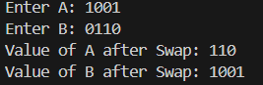

Question 36

Q: Program to find factorial of a number using function and return its value in the calling function

Source Code

// Program to find factorial of a number using function and return its value in the calling function

#include<stdio.h>

int factorial(int n){

    int i;

    for(i=n-1;i>=1;i--){

        n *=i;

    }

    return n;

}

int main(){

    printf("Program to find a factorial of a number.\n");

    int n,fac;

    printf("Enter Number: ");

    scanf("%d", &n);

    fac = factorial(n);

    printf("Fctorial of %d is %d",n,fac);

    return 0;

}

Output

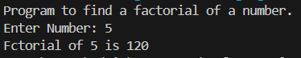

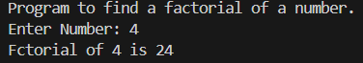

Question 37

Q: Program to find factorial of a number using recursion

Source Code

// Program to find factorial of a number using recursion

#include <stdio.h>

int factorial(int n) {

    if (n <= 1) {

        return 1;

    } else {

        return n * factorial(n - 1);

    }

}

int main() {

    printf("Program to find the Factorial of a number.\n");

    int n, fac;

    printf("Enter Number: ");

    scanf("%d", &n);

    if (n < 0) {

        printf("Factorial is not defined for negative numbers.\n");

        return 1;

    }

    fac = factorial(n);

    printf("Factorial of %d is %d\n", n, fac);

    return 0;

}

Output

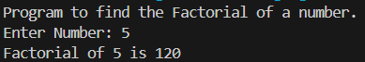

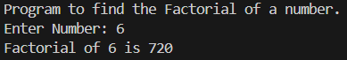

Question 38

Q: Program to display usage of static variables

Source Code

//Program to display usage of static variables

#include <stdio.h>

void countCalls() {

    static int count = 0;  // Static variable to keep track of function calls

    count++;                // Increment the count

    printf("Function called %d times\n", count);

}

int main() {

    printf("Demonstrating the usage of static variables:\n");

    printf("Value of Static variables retain between function calls.\n");

    // Call the function multiple times

    for (int i = 0; i < 5; i++) {

        countCalls();

    }

    return 0;

}

Output

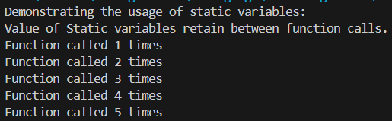

Question 39

Q: Program to display Fibonacci series using recursion.

Source Code

#include<stdio.h>

void main(){

    printf("Program to Print Fibonacci Numbers \n");

    int n,i=1,a=0,b=1;

    printf("Enter Number of Fibonacci Elements: ");

    scanf("%d", &n);

    printf("\nFibonacci Series: ");

    printf("\n%d\n%d",a,b);

    fibonacci(a,b,n,i);

}

void fibonacci(int a,int b, int n, int i){

    int f;

    f = a+b;

    a = b;

    b = f;

    if(i == (n-1)){

        return;}

    else{

        printf("\n%d", f);

        i++;

        fibonacci(a,b,n,i);

    }

}

Output

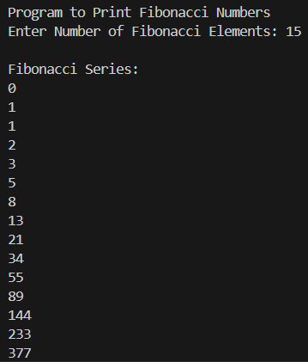

Question 40

Q: Program to find three digit armstrong numbers.

Source Code

#include<stdio.h>

#define YES printf("%d is an Armstrong Number.", og)

#define NO printf("%d is NOT an Armstrong Number.", og)

void main(){

    printf("Program to Find ArmStrong Number \n");

    int n, og, i, d, a = 0;

    printf("Enter Number: ");

    scanf("%d", &n);

    og = n;

    for(i=1;i<=3;i++){

        d = n%10;

        n /= 10;

        a += d*d*d;

    }

    (a == og ) ? YES : NO;

}

Output

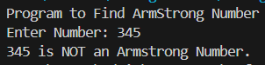 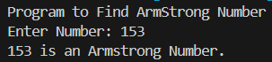

Question 41

Q: Read a number and heck if it is odd or even.

Source Code

// Check if a number is Even of Odd

#include <stdio.h>

int main() {

    int number;

    printf("Enter a number: ");

    scanf("%d", &number);

    if (number % 2 == 0) {

        printf("%d is an even number.\n", number);

    }

    else {

        printf("%d is an odd number.\n", number);

    }

    return 0;

}

Output

 

Question 42

Q: To check whether a given 5 digit number is palindrome or not.

Source Code

#include<stdio.h>

#define palindromeYes printf("%d is a Palindrome Number!", numOg)

#define palindromeNo printf("%d is NOT a Palindrome Number!", numOg)

void main(){

    int num, numOg;

    int i, isPalindrome;

    int start = 10000;

    printf("Enter 5 Digits: ");

    scanf("%d", &num);

    numOg = num;

    for(i=0;i<2;i++){

        if((num/start) == (num%10)){

            isPalindrome = 1;

            num /= 10;

            num %= (start/10);

            start/=100;

        }

        else{

            isPalindrome = 0;

            break;

        }

    }

    (isPalindrome == 1)? palindromeYes : palindromeNo;

}

Output





Question 43

Q: Program to show sum of n elements of array and there average.

Source Code

#include <stdio.h>

int main() {

    int n;

    printf("Enter the number of elements: ");

    scanf("%d", &n);

    int arr[n];

    int sum = 0;

    printf("Enter %d elements:\n", n);

    for (int i = 0; i < n; i++) {

        scanf("%d", &arr[i]);

        sum += arr[i];

    }

    float average = (float)sum / n;

    printf("Sum of elements: %d\n", sum);

    printf("Average of elements: %.2f\n", average);

    return 0;

}

Output

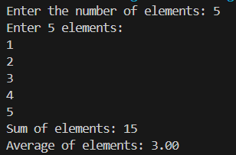

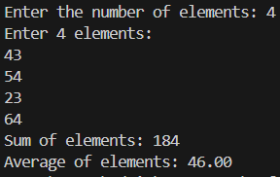

Question 44

Q: Program to find maximum & minimum interger in an array.

Source Code

#include <stdio.h>

int maximum(int n, int a[]){

    int max = a[0];

    for (int i = 1; i < n; i++){

        if (a[i] > max) {

            max = a[i];

        }

    }

    return max;

}

int minimum(int n, int a[]){

    int min = a[0];

    for (int i = 1; i < n; i++){

        if (a[i] < min) {

            min = a[i];

        }

    }

    return min;

}

int main() {

    int n,max,min;

    printf("Enter the number of elements: ");

    scanf("%d", &n);

    int arr[n];

    printf("Enter %d elements:\n", n);

    for (int i = 0; i < n; i++) {

        scanf("%d", &arr[i]);

    }

    max = maximum(n, arr);

    min = minimum(n, arr);

    printf("Max Number in Array is %d\n", max);

    printf("Max Number in Array is %d\n", min);

    return 0;

}

Output

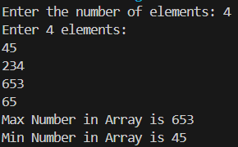 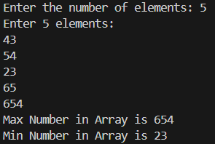

Question 45

Q: Write a Program to perform Linear search on an array.

Source Code

//Program to perform Linear search on an array.

#include<stdio.h>

int main(){

    int elm,arr[50],i,srch,flag;

    printf("How Many Elements you want to Enter: ");

    scanf("%d", &elm);

    for(i=0;i<elm;i++){

        printf("Enter Element %d: ", i+1);

        scanf("%d", &arr[i]);

    }

    printf("Enter the Integer to Search: ");

    scanf("%d",&srch);

    for(i=0;i<elm;i++){

        if(arr[i] == srch){

            flag = 1;

            break;

        }

    }

    if(flag == 1){

        printf("%d found at %d position", srch,i+1);

    }

    else{

        printf("%d not in Array!", srch);

    }

    return 0;

}

Output

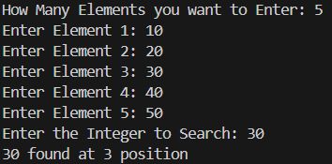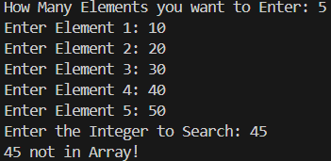

Question 46

Q: Program to generate reverse array for a given array.

Source Code

//Program to generate reverse array for a given array.

#include<stdio.h>

int main(){

    int arr[50],arrDup[50],elm,i;

    printf("How Many Elements you want to Enter: ");

    scanf("%d", &elm);

    for(i=0;i<elm;i++){

        printf("Enter Element %d: ", i+1);

        scanf("%d", &arr[i]);

    }

    for(i=elm;i>=1;i--){

        arrDup[elm-i] = arr[i-1];

    }

    for(i=0;i<elm;i++){

        printf("%d ", arrDup[i]);

    }

    return 0;

}

Output

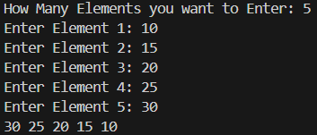

Question 47

Q: Program to perform Matrix Operations (switch-case):

Addition, Subtraction, Multiplication and Transpose.

Source Code

/*Program to perform Matrix Operations (switch-case):

Addition, Subtraction, Multiplication and Transpose*/

#include<stdio.h>

void inputMatrix(int n[3][3]){

    int i, j;

    printf("Enter a 3x3 Matrix:\n");

    // Input values in the matrix

    for(i = 0; i < 3; i++){

        for(j = 0; j < 3; j++){

            printf("Enter number @ row %d column %d: ", i + 1, j + 1);

            scanf("%d", &n[i][j]);

        }

    }

}

void printMatrix(int a[3][3]){

    // Print the matrix

    int i, j;

    printf("Matrix:\n");

    for(i = 0; i < 3; i++){

        for(j = 0; j < 3; j++){

            printf("%d ", a[i][j]);

        }

        printf("\n");

    }

}

void addMatrix(int a[3][3], int b[3][3], int result[3][3]){

    // Adding two matrices

    int i, j;

    for(i = 0; i < 3; i++){

        for(j = 0; j < 3; j++){

            result[i][j] = a[i][j] + b[i][j];

        }

    }

}

void subtractMatrix(int a[3][3], int b[3][3], int result[3][3]){

    // Subtracting two matrices

    int i, j;

    for(i = 0; i < 3; i++){

        for(j = 0; j < 3; j++){

            result[i][j] = a[i][j] - b[i][j];

        }

    }

}

void multiplyMatrix(int a[3][3], int b[3][3], int result[3][3]){

    // Multiplying two matrices

    int i, j, k;

    for(i = 0; i < 3; i++){

        for(j = 0; j < 3; j++){

            result[i][j] = 0;

            for(k = 0; k < 3; k++){

                result[i][j] += a[i][k] * b[k][j];

            }

        }

    }

}

void transposeMatrix(int a[3][3], int result[3][3]){

    // Transposing the matrix

    int i, j;

    for(i = 0; i < 3; i++){

        for(j = 0; j < 3; j++){

            result[j][i] = a[i][j];

        }

    }

}

int main(){

    int a[3][3], b[3][3], result[3][3];

    char choice;

    printf("Choose operation:\n");

    printf("Addition (+)\nSubtraction (-)\nMultiplication (x)\nTranspose (t)\n");

    scanf(" %c", &choice);  //space before %c to ignore newline character from previous input

    switch (choice){

        case '+':

            printf("Input first matrix:\n");

            inputMatrix(a);

            printf("Input second matrix:\n");

            inputMatrix(b);

            addMatrix(a, b, result);

            printf("Result of matrix addition:\n");

            printMatrix(result);

            break;

        case '-':

            printf("Input first matrix:\n");

            inputMatrix(a);

            printf("Input second matrix:\n");

            inputMatrix(b);

            subtractMatrix(a, b, result);

            printf("Result of matrix subtraction:\n");

            printMatrix(result);

            break;

        case 'x':

            printf("Input first matrix:\n");

            inputMatrix(a);

            printf("Input second matrix:\n");

            inputMatrix(b);

            multiplyMatrix(a, b, result);

            printf("Result of matrix multiplication:\n");

            printMatrix(result);

            break;

        case 't':

            printf("Input matrix to transpose:\n");

            inputMatrix(a);

            transposeMatrix(a, result);

            printf("Transpose of the matrix:\n");

            printMatrix(result);

            break;

        default:

            printf("Invalid operation!\n");

            break;

    }

    return 0;

}

Output

|  |  |
| --- | --- |
| Choose operation:  Addition (+)  Subtraction (-)  Multiplication (x)  Transpose (t)  +  Input first matrix:  Enter a 3x3 Matrix:  Enter number @ row 1 column 1: 1  Enter number @ row 1 column 2: 2  Enter number @ row 1 column 3: 3  Enter number @ row 2 column 1: 4  Enter number @ row 2 column 2: 5  Enter number @ row 2 column 3: 6  Enter number @ row 3 column 1: 7  Enter number @ row 3 column 2: 8  Enter number @ row 3 column 3: 9  Input second matrix:  Enter a 3x3 Matrix:  Enter number @ row 1 column 1: 9  Enter number @ row 1 column 2: 8  Enter number @ row 1 column 3: 7  Enter number @ row 2 column 1: 6  Enter number @ row 2 column 2: 5  Enter number @ row 2 column 3: 4  Enter number @ row 3 column 1: 3  Enter number @ row 3 column 2: 2  Enter number @ row 3 column 3: 1  Result of matrix addition:  Matrix:  10 10 10  10 10 10  10 10 10 | Choose operation:  Addition (+)  Subtraction (-)  Multiplication (x)  Transpose (t)  x  Input first matrix:  Enter a 3x3 Matrix:  Enter number @ row 1 column 1: 1  Enter number @ row 1 column 2: 2  Enter number @ row 1 column 3: 3  Enter number @ row 2 column 1: 4  Enter number @ row 2 column 2: 5  Enter number @ row 2 column 3: 6  Enter number @ row 3 column 1: 7  Enter number @ row 3 column 2: 8  Enter number @ row 3 column 3: 9  Input second matrix:  Enter a 3x3 Matrix:  Enter number @ row 1 column 1: 1  Enter number @ row 1 column 2: 2  Enter number @ row 1 column 3: 3  Enter number @ row 2 column 1: 4  Enter number @ row 2 column 2: 5  Enter number @ row 2 column 3: 6  Enter number @ row 3 column 1: 7  Enter number @ row 3 column 2: 8  Enter number @ row 3 column 3: 9  Result of matrix multiplication:  Matrix:  30 36 42  66 81 96  102 126 150 |
| Choose operation:  Addition (+) Subtraction (-) Multiplication (x) Transpose (t): t  Input matrix to transpose:  Enter a 3x3 Matrix:  Enter number @ row 1 column 1: 1 Enter number @ row 1 column 2: 2  Enter number @ row 1 column 3: 3 Enter number @ row 2 column 1: 4  Enter number @ row 2 column 2: 5 Enter number @ row 2 column 3: 6  Enter number @ row 3 column 1: 7 Enter number @ row 3 column 2: 8  Enter number @ row 3 column 3: 9  Transpose of the matrix:  Matrix:  1 4 7  2 5 8  3 6 9 | |

Question 48

Q: Program to read character array using getchar() in do-while loop and print it.

Find its length and number of vowels (Case-sensitive)

Source Code

/*Program to read character array using getchar() in do-while loop and print it.

Find its length and number of vowels (Case-sensitive)*/

#include<stdio.h>

int main() {

    char str[100],ch;

    int length = 0,vowels = 0,i = 0;

    printf("Enter a string (end input with a newline): ");

    do {

        ch = getchar();

        str[i++] = ch;

    }while(ch != '\n' && i < 100);

    str[i-1] = '\0';

    // Loop to calculate length and number of vowels

    for(i = 0; str[i] != '\0'; i++) {

        length++;

        if(str[i] == 'A' || str[i] == 'E' || str[i] == 'I' || str[i] == 'O' || str[i] == 'U' ||

           str[i] == 'a' || str[i] == 'e' || str[i] == 'i' || str[i] == 'o' || str[i] == 'u') {

            vowels++;

        }

    }

    printf("You entered: %s\n", str);

    printf("Length of the string: %d\n", length);

    printf("Number of vowels: %d\n", vowels);

    return 0;

}

Output

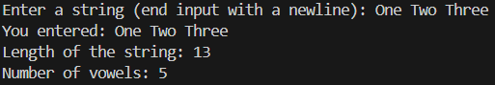

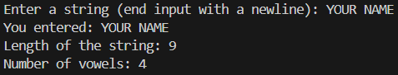

Question 49

Q: Program to find reverse of a string (without inbuilt function).

Source Code

//Program to find reverse of a string (without inbuilt function).

#include<stdio.h>

int main(){

    char str[100],strRev[100],ch;

    int length = 0,vowels = 0,i = 0,len;

    printf("Enter a string: ");

    do {

        ch = getchar();

        str[i++] = ch;

    }while(ch != '\n' && i < 100);

    str[i-1] = '\0';

    for(len=0;str[len]!='\0';len++); // to calculate length of string array

    i=0;

    while(str[i]!='\0'){

        strRev[i] = str[len-1];

        i++;

        len--;

    }

    strRev[i] = '\0';

    for(i=0;strRev[i]!='\0';i++){

        printf("%c", strRev[i]);

    }

    return 0;

}

Output





Question 50

Q: Program to Compare and Concatenate two string (without inbuilt function).

Source Code

//Program to compare and concatenate two string (without inbuilt function).

#include<stdio.h>

int main(){

    char str1[50],str2[50];

    printf("\nEnter Two Strings: ");

    scanf("%s %s", str1, str2);

    char fullStr[150];

    int i,j;

    //Concatenating Strings

    for(i=0; str1[i]!='\0'; i++){

        fullStr[i] = str1[i];

    }

    fullStr[i] = ' ';

    for(j=0; str2[j]!='\0'; j++){

        fullStr[i+j+1] = str2[j];

    }

    fullStr[i+j+1] = ' ';

    printf("Concatenated String is:\n");

    printf("%s", fullStr);

    //Comparing Strings

    i=0;

    while(str1[i] == str2[i] && str1[i] != '\0' && str2[i] !='\0'){

        i++;

    }

    if(str1[i]=='\0' && str2[i]=='\0'){

        printf("\nBoth the Strings have Equal Values!");

    }

    else{

        printf("\nStrings are Not Equal!");

    }

    return 0;

}

Output

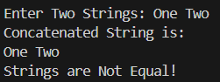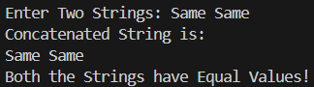

Question 51

Q: Program to copy a string to another string (without inbuilt function.)

Source Code

//Program to copy a string to another string (without inbuilt function.)

#include<stdio.h>

int main(){

    char str[50], strCopy[50];

    int i;

    printf("Enter String: ");

    scanf("%s", str);

    for(i=0;str[i]!='\0';i++){

        strCopy[i] = str[i];

    }

    printf("The Copied String is %s.\n", strCopy);

    return 0;

}

Output





Question 52

Q: Program to show the use of string function: strcpy(), strcat(), strcmp(), strlen().

Source Code

//Program to show the use of string function: strcpy(), strcat(), strcmp(), strlen().

#include<stdio.h>

#include<string.h>  // Include the string.h library for string functions

int main() {

    char str1[50], str2[50], str3[50];

    // strcpy() - Copies the contents of one string into another

    printf("Enter the first string: ");

    gets(str1);

    strcpy(str3, str1);

    printf("After copying, str3 = %s\n", str3);

    // strcat() - Concatenates (appends) one string at the end of another

    printf("Enter the second string: ");

    gets(str2);

    strcat(str1, str2);

    printf("After concatenation, str1 = %s\n", str1);

    // strcmp() - Compares two strings lexicographically

    if(strcmp(str1, str3) == 0)

        printf("str1 and str3 are the same.\n");

    else

        printf("str1 and str3 are different.\n");

    // strlen() - Finds the length of a string

    printf("Length of str1: %lu\n", strlen(str1));

    printf("Length of str2: %lu\n", strlen(str2));

    printf("Length of str3: %lu\n", strlen(str3));

    return 0;

}

Output

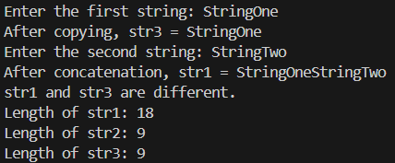

Question 53

Q: Program to find if a given string is palindrome or not.

Source Code

//Program to find if a given string is palindrome or not.

#include<stdio.h>

#define palindromeYes printf("%s is a Palindrome Number!", str)

#define palindromeNo printf("%s is NOT a Palindrome Number!", str)

int main(){

    char str[50];

    int len,i, isPalindrome;

    printf("Enter String: ");

    scanf("%s", str);

    for(len=0;str[len]!='\0';len++);

    for(i=0;i<(len/2);i++){

        if(str[i] != str[len-1-i]){

            isPalindrome = 0;

            break;

        }

        else{

            isPalindrome = 1;

        }

    }

    (isPalindrome)? palindromeYes : palindromeNo;

    return 0;

}

Output







Question 54

Q: Program to define pointer variables for int, char, float.

Source Code

// program to define pointer variables for int, char, float.

#include<stdio.h>

int main(){

    int   A = 10,*a;

    char  B = 'H', *b;

    float C = 10.5, *c;

    a = &A;

    b = &B;

    c = &C;

    printf("Value of A: %d\n", A);

    printf("Address of A: %d\n", &A);

    printf("Value of Pointer *a: %d\n", a);

    printf("Address of Pointer *a: %d\n", &a);

    printf("Value @ Address of A: %d\n", *a);

    printf("\n");

    printf("Value of B: %c\n", B);

    printf("Address of B: %d\n", &B);

    printf("Value of Pointer *b: %d\n", b);

    printf("Address of Pointer *b: %d\n", &b);

    printf("Value @ Address of B: %c\n", *b);

    printf("\n");

    printf("Value of C: %d\n", C);

    printf("Address of C: %d\n", &C);

    printf("Value of Pointer *c: %d\n", c);

    printf("Address of Pointer *c: %d\n", &c);

    printf("Value @ Address of C: %d\n", *c);

    printf("\n");

    return 0;

}

Output

